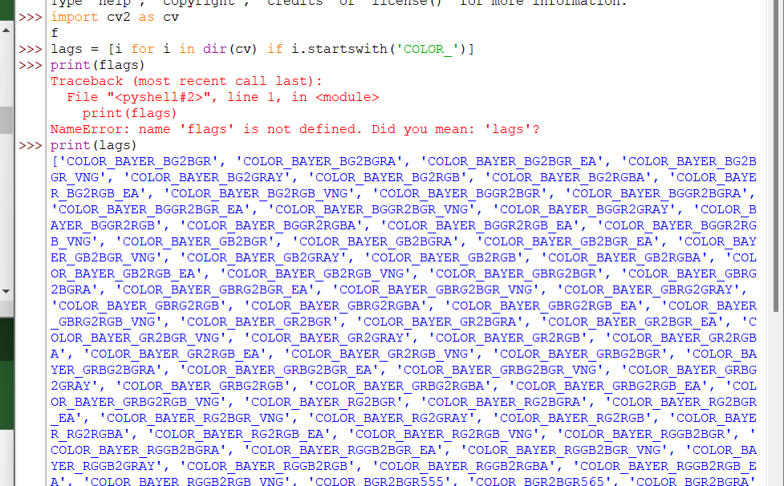

Flags

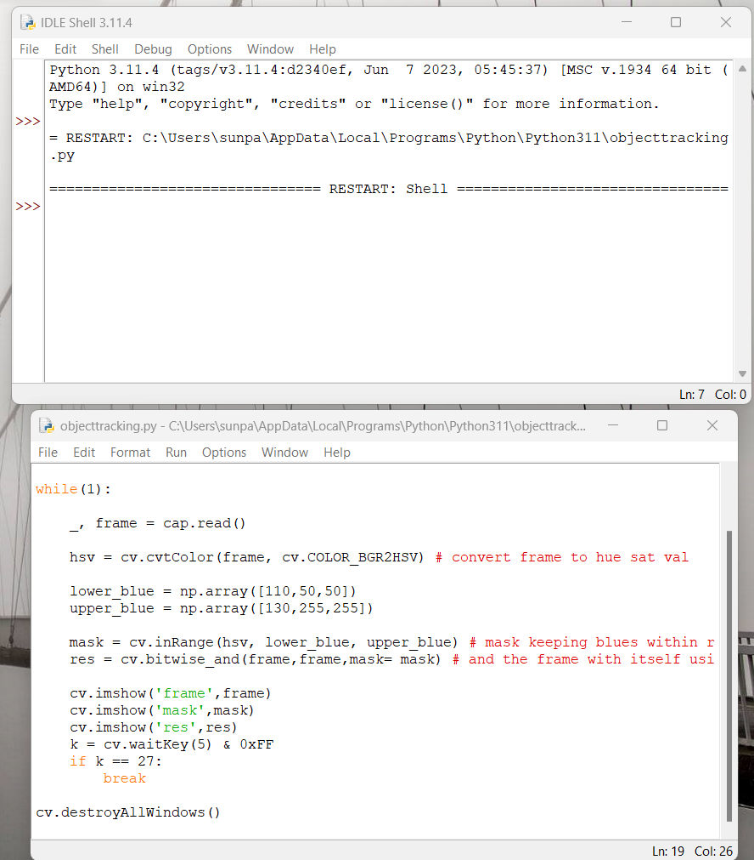

Code to show mask of blue pixels in frame within certain bounds, works

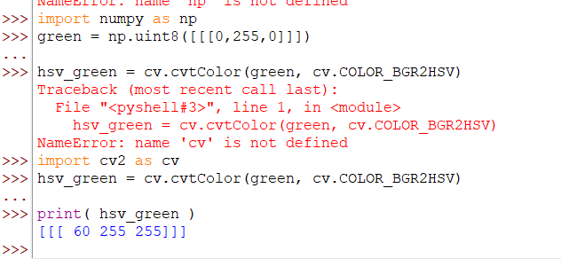

Code to convert BGR to HSV, use the first value, hue, to make a hue range

To extract red, blue or green objects simultaneously, you would need an exclusive or function or an if else statements